Data & Graphing in 
An Introduction
R for Biologists 2015
Tom Cameron

on behalf of the Essex R Team

With thanks to Richard Gunton, Tim Benton (Leeds), Andy Beckerman (Sheffield) and Ken Wilson (Lancaster).
Background
Introduction to R
What is R?
R is best described as a software environment in which work with data. It can be used for statistics but can also be used for programming and data manipulation etc. There is a commercial product which has a shared genealogy called S+ (sold by TIBCO) which was developed first. As a commercial (expensive) product it has a much more user-friendly front-end (e.g. menus, spreadsheets, editable graphs) but works in similar ways.

R is an object-oriented package. This means that all items created in R are distinct, editable objects. So, for example, when you perform a linear model, such as a regression, an object is created (of class lm) which can then be dissected and edited as necessary. The object is like a filing cabinet drawer, with a tabbed file for “coefficients” containing a piece of paper with “slope”, and another with “intercept”; a tabbed file for the “list of residuals”; a tabbed file for “fitted values” etc. This structure is useful when performing repetitive analyses, where only parts of the analysis (such as the coefficients) are important.

R is command-line driven (i.e. you have to type a command, or series of commands – a script – to do anything). This means (a) you need to know what you are doing but (b) you can do anything in anyway with great flexibility. Modern statistics, relying largely on R and S+, has been revolutionised in the last decade. R will both change the way you do statistics and change your mental approach to analysis.

R is a modular programme. It comes with a set of base packages that allow for extensive plotting and slightly more than basic statistics (all linear modelling). Additional packages – which can be written by anyone and do anything – need to be loaded using the library command to memory usage low and speed high! There are hundreds of add-on packages that may be useful to you as you encounter new questions during your studies.

What can R do?
• Exploratory data analysis (summaries, normality plots, correlations)
• Advanced statistics (generalised linear modelling, PCA analysis, bootstrapping, spatial analysis)
• Programming (it is an advanced programming language)
• Simple and complex graphics (2D and 3D plots)
- Data manipulation as you might do in Excel or a database programme

Is R complicated?
- R is as simple or as complex as you want it to be.
- It is an environment used by all people at the cutting-edge (statisticians as well as ecologists)
- There is a steep learning curve, but invest in learning and it will pay dividends
- There is a big user-community to provide help when you can’t find your own route round the problem. Users often have written packages to use families of techniques so the ability to do new things is growing fast..
- http://www.r-project.org/ is the home of R and the community with lots of code, examples, packages, Wikis etc etc.
Step 1. Getting in and out!

Before you start
All our files are placed in MOODLE at:
https://moodle.essex.ac.uk/course/view.php?id=5084
All the data files are placed as Excel files and you need to download them and then convert them from excel format to csv (comma separated values). It makes sense therefore to copy the files onto a dedicated set of folders on your Network drive or laptop and set this as your working directory.
Go to your Network drive (M:\\, from within “my computer”) and make a new folder called R_course. Within this folder make two new folders: practicals and lectures. With the practical data, you will then need to go to the folder, open the file and “save as csv”(which is about 10 lines down in the menu box that defaults to “Microsoft Office Excel Worksheet (.xls)”.
When you get going in R you can use the following command:
setwd(“M:\\R-course\\practicals”)
and that will mean that opening and saving files to this folder will be easy because it will be the first place that R goes when you do any file-based operation. Alternatively, you can set your working directory using the “change dir…” command in the file menu.
Starting R
• R runs on all platforms – windows, Macintosh, and Linux. For your own computers, download it from CRAN (the Comprehensive R Network Archive) (follow links from http://www.r-project.org/)
• Open R via the Start button>Programs>Statistics in Windows on a University Computer
• Open Rstudio via the same procedure or double click ICON
• R runs as an application with a console for input and output in Windows and Mac; it runs as an X-windows application in Linux, and in Mac if you want, and in Windows via CYGYN, if you really want to be a geek.
Getting to Grips with a Command Line Program
- The console in windows has a single panel for input and for output. The prompt on all platforms is > and there should be a flashing line next to that.
- There are three things you can do with this console: type, copy and paste.
- See the “introduction to R” manual on the R home page for more info.

- The first most important thing to remember is how to get help
>help(lm)or >?lm #opens a help window on “lm” or linear models
>help.search(“lm”) #searches for any command with text “lm” in
>help.start() #opens a new window with all the locally stored help files
And remember the R home page (http://www.r-project.org/) is a repository for many different bits of info (see the FAQs for many tips from where others have been where you are now!)
On the R-home page follow links to Search and R Site Search which will search through all R documentation (including the mailing lists) and is a very useful way of seeing if anyone has asked your question before!
Note: One of the most difficult things to learn about R is that you often need to know how to do something (e.g. the command name) before you know what to ask in the help facility. The "?" command is therefore most useful if you know a command and want help on syntax etc. Help.search() is more able to search for more general terms. Apropos(function.name) is another useful search term. Sometimes the help facility is loaded when you load a library so you have to already know what package you need. If you get lost use the user-community. We have all started off and had to ask – sharing ideas on how to do things is inherently part of using R. But no-one likes having their time wasted, so make reasonable attempts to solve problems yourself first – it is also a good route to learning.
- The next most important thing is that R is case sensitive. mean(x) will give you the average of the object x, Mean(x) or average(x) won’t.
- The last most important thing is how to quit R and how to interrupt R if something seems amiss. To escape from a “hung” process – one that won’t stop or is clearly not what you want, you can hit escape, ctrl-C or press the stop button, or use whatever method is necessary to force R to quit (e.g. CTRL-ALT-DEL or CMD-Force Quit in OSX). Quit via typing q or using the file>exit command.
Where are things in R?
R is an object-orientated programme. This means that data that you import into R receives a name and can have attribute associated with it. Statistical models that you create may all have names and carry a variety of attributes.
Typically, data is stored in arrays (which you can think of as a spreadsheet, or collection of columns). The data can be manipulated as a whole array (e.g. matrix algebra, or transforming a whole set of columns together) or parts of the dataset can be manipulated by “taking them” from the array. In this case, each subset of the data you may play with (think of it as a column from an SPSS datasheet) is a single-columned array (or vector).
x<-c(1:10)
y<-runif(10)
data<-data.frame(x,y)

This set of commands first creates two data objects, x & y. X is a sequence of integers from 1, 2, 3…10 and y is a set of 10 random numbers from a uniform distribution. The first command is translatable as “object x is created by concatenating (joining) the numbers 1 through to 10”. The second command as “object y is created by calling 10 random numbers from a random uniform distribution”. The third command is “the object data is created as a data frame – see below – containing objects x and y”. The “<-“ is the universal assignment operator in R (don’t use the = sign which has a different meaning). Typing the name of the object at the prompt will give you a printout of what it contains (which for a data frame is akin to looking at the spreadsheet).
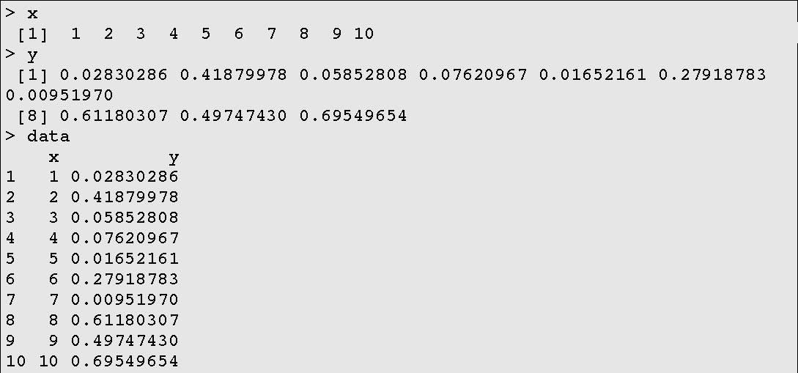

Each of these objects is stored in the working directory database built into R. You can locate, rename and delete objects from the database.
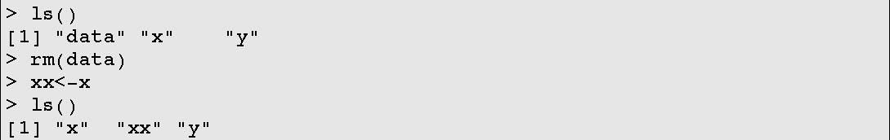
Here we locate and list the objects using the function ls(); then we remove the object called data from the database, using the function rm() and create a new object xx that is a duplicate of x; finally, we re-list the objects to see what we have done.

Recall that objects often have attributes and accessories. This will be very important for understanding the statistical models.
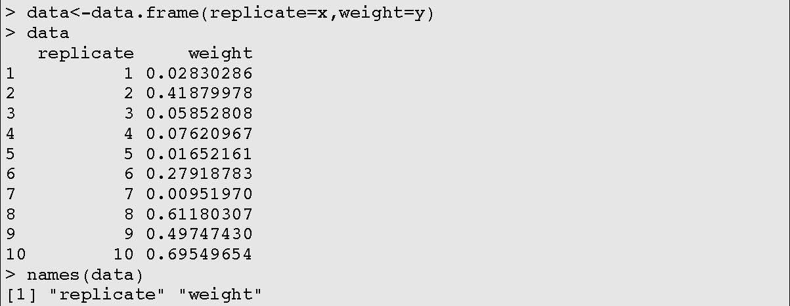
Here we remake the data object, but add names to the columns that we might understand; then we use the function names() to have it tell us what the component pieces of the dataset are called. This is handy for large datasets with many columns.
Note, all data.frames have a row.names attribute (with the default being a simple number as above). Sometimes it is useful to set the row names (e.g. where each row is a site). This is simple to do. row.names(data)<-c(“siteA”, “siteB”...”siteJ”)
Finally, R has a memory. If you use the up arrow now (press it once), you will notice that the previous command appear (hit return to execute it again). This works in both directions for multiple events. (try it)
Excel to R – data storage and import
R possesses a simple command for reading in datasets from excel. YOU NEED TO SAVE THE EXCEL SPREADSHEET AS A CSV FILE (comma separated values – it is an option under the “save as type” option in the “save as” dialogue box). The first row of this worksheet should contain the names of the columns that you want to use.
The following box shows how to read a file called file.csv from folder "mydata" on drive M. Note our use of the # symbol as well. This is a comment and would not be evaluated by R. Note as well our specification of windows and non-windows syntax.. names(data2) reveals that it is a 3 column data set and typing data2 prints to the screen the data itself.
data2<-read.csv("M://mydata//file.csv") #reads in data
names(data2)#names list columns etc
data2#just typing the object name prints the object
data<-data.frame(x,y)

Note: if you have set the working directory as one different from the default, and the file is within that directory then read.csv(“file.csv”) should work

Saving Things in R
The easiest way to save your work session in R is to save the workspace. ls() produces a list of objects in your workspace, and this database, combined with the output and history of commands can be saved when you quit by clicking “yes” to the save “workspace image” question. By reloading the image, you reload everything you have done to now in your session. NOTE: In R studio this is like saving a “Project”.
What format may data take?
- Numeric data – when you read a file into R, or create an object, lists of numbers will be classed as a list. Numeric vectors will be considered continuous numeric vectors for analysis – e.g. a covariate. To create a factor (a variable with categories), R requires that you specify the vector/column you are interested in as a factor.
- In this exercise, we create a vector of codes for an experimental treatment using firstly a list: c(1,1,1,1,1,2,2,2,2,2) – and secondly using the more efficient rep (for repeat) command : rep(c(1,2),each=5).
- Note how you can use rep to create a more complicated structure to the vector of codings, and how it need not be numbers.
- Having created the object with the list of levels, we make this object a factor so that R “knows” to treat the values as a categorical rather than continuous variable in your analyses.
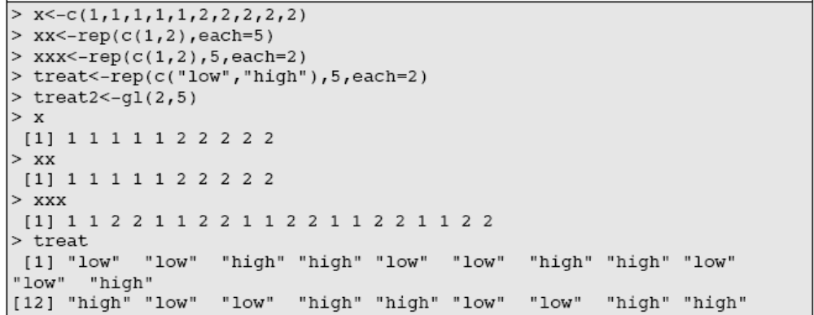
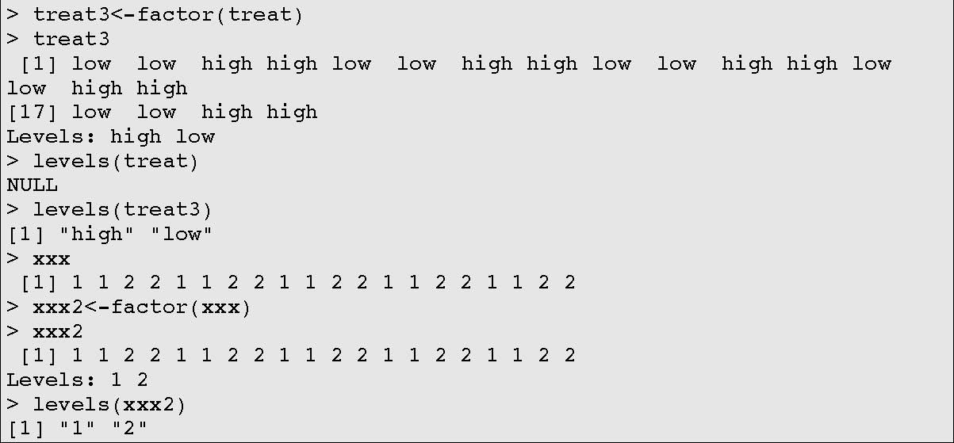
- Note how you can easily determine if something is a factor by asking for its levels().
ALTERNATIVELY and even better, you can also use gl() (for “group levels”) to make factors – e.g. gl(2,5) will generate a factor with levels 1 and 2, each 5 times, and there is no need to specify it as a factor (note the specification of the Levels!) . gl(2, 5, label = c("low", "high")) also allows factor levels to be named
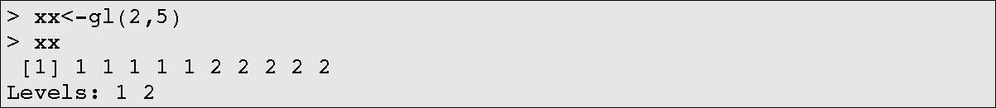

How can R package data?
R recognises four types of data sets:
- data.frame: This is the main data-type. Like an excel datasheet, a data.frame is a 2-dimensional table, which can comprise data of more than one mode (e.g. numerics and characters).
- matrix: This is also a 2-dimensional table, but comprises data of only one mode (either numerical data or character strings, but not both). This data format is particularly useful for fast data manipulation and matrix modelling.
- vector: This is a 1-dimensional array containing elements which all have the same mode (e.g. a string of numbers or a string of names).
- list: This is a collection of other objects (e.g. the elements of a regression model).

Accessing Portions of a data.frame
When you import a data frame, or create one in R, you may want to access one column or row of the data, for manipulation etc. There are two ways to do this. First, data frame columns names are accessible by their name – dataframename$columnname.

Note how we specified treatment as a factor and that R recognised it as a factor when we specified it as data$ treatment.
> y<-c(3,4,3,3,4,5,6,8,7,8)
> x<-rep(c(1:2),each=5)
> data<-data.frame(treatment=factor(x),weight=y)
> data

treatment weight
1 1 3
2 1 4
:
10 2 8
> data$weight
[1] 3 4 3 3 4 5 6 8 7 8
> log(data$weight)
[1] 1.098612 1.386294 1.098612 1.098612 1.386294 ...
[9] 1.945910 2.079442
> data2<-data.frame(data,logwt=log(data$weight))
> data2

treatment weight logwt
1 1 3 1.098612
2 1 4 1.386294
:
10 2 8 2.079442
Note how we created a new object, logwt, inside the command to create a new data.frame called data2.

We can also access portions of the data frame using the matrix notation (either to analyse them or assign them to different objects). Each row and column of a data frame and matrix carries a position index: (i,j).
Remember for matrices the notation for cells is (Rows, Columns): my maths teacher said “RC, remember RC, matrices, like the Pope, are Roman Catholic”. So, [,j] corresponds to all rows in column j and [i,] corresponds to all columns in row i. data2[1,]will give you row 1; data2[,1] will give you column 1 and data2[1,1] will give you the cell in row1, column 1.
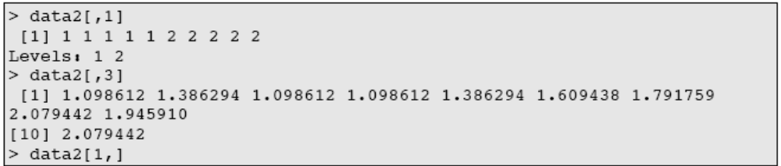
These tools are incredibly useful for sub-setting data. For example, let’s say we only want to examine the weights of treatment 1 we can use the following command data[data$treatment==”1”,]. Let’s pause to dissect this command: The outside portion data[data$treatment==”1”,] says select rows of data from the object data. The inner bit data[data$treatment==”1”,] specifies values where the level of the factor “treatment” equals one. So the whole commands subsets the data to extract the treatment one data.
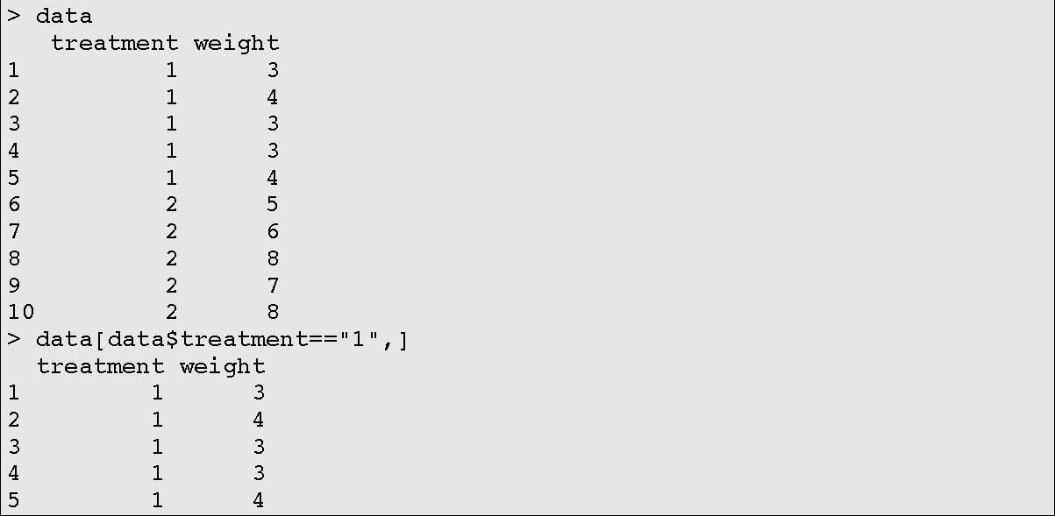
? What command allows you to access rows corresponding to treatment 2?
? What command allows you to access the first column of rows with treatment 1?

Step 2.Playing with some real data!
Step 1 highlighted how to get data in and out of R. Here we play with hand entered data to practice with R syntax. We could just as easily create the data below in excel and import it.
It is good practice to write all the commands, not in the command line, but in a file called a script. You can save this script (a list of commands) and redo any part of your list by highlighting the text (using the mouse) and pressing CTRL+R (or right click the mouse and use the “run line or selection” command). So for the next block of work, create (and save as you go along) a script file (start it with “file>new script”, or CTRL+N)
Inputting data into R
• Type in the following 2 columns of data and create a data frame called cherry. DIAM refers to diameter of cherry trees (cm), HEIGHT refers to their height (m).

Type >cherry to check the data is there.
diam<-c(8.3,8.5,8.8,9.1,9.5,10.8,9.5,10.1,11.1,11.4)
height<-c(66,65,63,72,81,83,77,75,80,79)
cherry<-data.frame(diam,height)

DIAM | HEIGHT
8.3 | 66
8.5 | 65
8.8 | 63
9.1 | 72
9.5 | 81
10.8 | 83
9.5 | 77
10.1 | 75
11.1 | 80
11.4 | 79

Summarising your data
- R has a number of built in commands to help summarize data. These can work on specific pieces of data frames or on the entire data frame
- mean(), sd(), length(),dim(), summary()
- Note how mean(cherry) produces a set of means, one for each column.
- So does sd(), for the standard deviation.
- summary() produces a range of statistics, including the mean.
- dim() signified dimension, and provides a summary of the number of rows (10) and columns (2) – remember RC for finding your way round a matrix's subscripts.
- length() produces the second element of dim() when applied to a data frame, or the count/length of a specific column (e.g. length(cherry$diam) = 10, the number of elements in diam.
- Try str(cherry). What does it tell you? Str stands for structure.
- now we can use combinations of commands to create the standard error of any column of data!

The SE is SD/sqrt(sample size). It is a useful entity to calculate, but writing the command out in full is a pain. So, let’s write a function to do it for you. Write the following:
se<-function(x) {
sd(x)/sqrt(length(x))
}
This creates a new function that, given an object x, will estimate its SE. The function is defined by the code between the { }. One can write functions to do anything, and it makes doing repetitive tasks much easier!

Try it with se(cherry$diam)

Keep a text file of functions you write, so you can cut and paste them into R each time (if you don’t load a saved workspace).

Plotting Data – The Basics
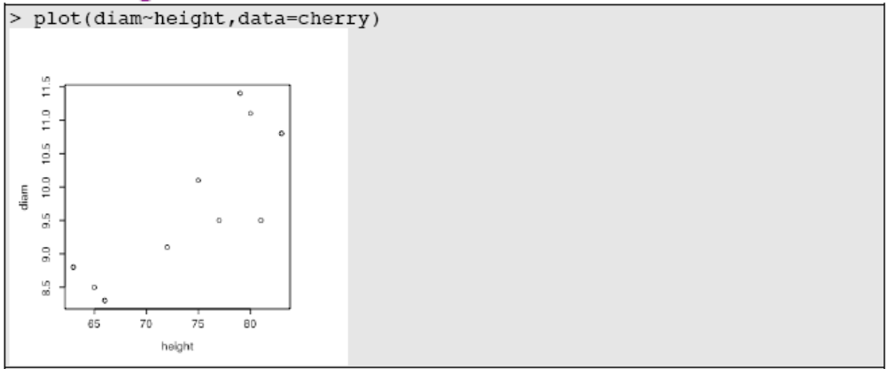
The command plot() is the general plotting command from which much else flows. Try ?plot . The command above is plot(y~x,data=dataframe), with the dataframe being needed to specify where the x and y come from. The ~ is the convention for specifying formulae, so y~x is “y as a function of x”. plot(dataframe$y~dataframe$x) works because the formula also has the “address” for where the data comes from). plot(x,y) works the same as plot(y~x). Try plot(dataframe) … this is useful in exploring data.
Now, let’s add a title, connect the dots, and change the colour of the dots:
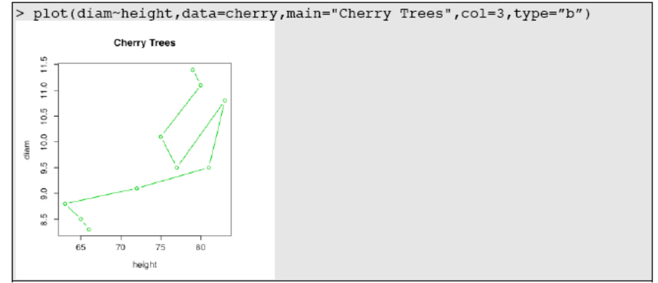
note how the call type=”b” specified lines connecting dots (the "b" is for "both" points and line). Type=”l” is line only; the default is dot only (see ?plot for details). TRY THEM
Now, let’s adjust aspects of the labels.
The par command (for parameter) sets all sorts of layout-type parameters, of which mar (“for margins”) is only one. Here we specify plot margins to accommodate label text that is large. The labels are specified as a list, with cex = 1.5 corresponding to the font/point size (or in R terms the “character expansion”, cex), and “Height” or whatever you type in, corresponding to the label itself.
par(mar=c(5,5,5,5))
plot(diam~height,data=cherry,main="Cherry Trees", xlab=list(cex=1.5, "Height"), ylab=list(cex=1.5, "Diameter"))

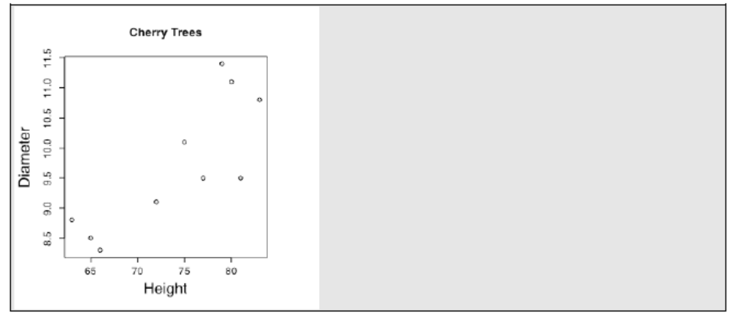
Note: If you don’t want to vary the height of the letters you can use the more simple form of plot(diam,height,data=cherry,ylab=”ylabel”,xlab=”xlabel”).

What happens if you set mar=c(1,2,3,4)?

Now, let’s adjust the x and y-axis dimensions using xlim and ylim (for “limits of x”).
plot(diam~height,data=cherry,main="Cherry Trees", xlab=list(cex=1.5, "Height"), ylab=list(cex=1.5, "Diameter"), ylim=c(0,14), xlim=c(50,100))

Adding a linear regression line to the plot.
- This is a straightforward process involving your first bit of statistics in R!
- First, re-plot the data on the default axis sizes (i.e. without the xlim and ylim).
- Second, create an object called m1 that is a simple linear regression of diameter versus height. lm() is linear model, diam~height indicates “predict diam as a function (~) of height”, and data= specifies the use of the data frame cherry.
m1<-lm(formula=diam~height,data=cherry).

- Check to see where the model is ( ls() ); type m1 and see what happens? summary(m1)? anova(m1)? Just hints for the future.....
- Finally, plot the line on the graph. abline(coef(m1)) plots a line using the coefficients of m1, which are the intercept and the gradient/slope of the regression!
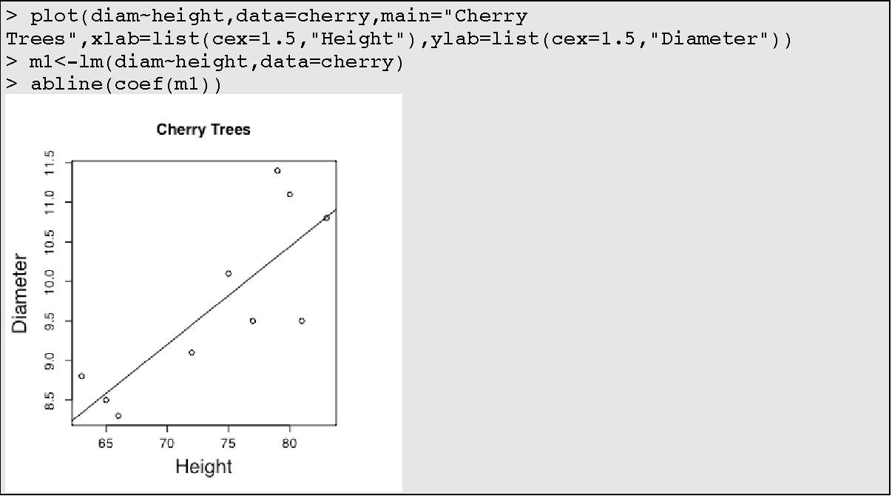

Note, as you get more proficient, you’ll find places where you can shortcut commands a bit. This is normally possible where the function you are calling has defaults that mean it expects to see something in a particular place. For example lm(formula=diam~height, data=cherry) is longer than lm(diam~height,cherry). Also, abline(m1) is as good as abline(coef(m1)).

Other Graphs
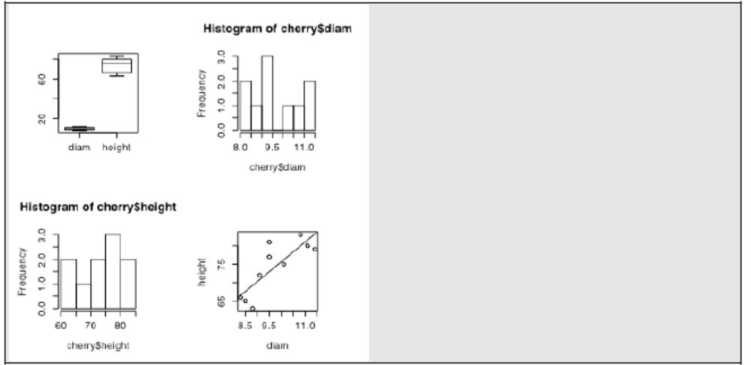
Sometimes it is useful to place more than one graph in a figure. Here, we set-up a page to accommodate 4 figures and place a boxplot, two histograms, and the plot of the data relationship on the same figure. Note how the par(mfrow=c(2,2)) command parameterizes the graph (par) to have many figures (mf), ordered by 2 rows and two columns.
par(mfrow=c(2,2))
boxplot(cherry)
hist(cherry$diam)
hist(cherry$height)
plot(cherry$height~cherry$diam)
m1<-lm(height~diam, data=cherry)
abline(coef(m1))

Note. We can very easily produce a diagnostic plot for a linear model using the par command and the mfrow=c(2,2) syntax. plot(x), where x is an lm model object, has a built in process for a linear model, producing a residuals vs. fitted plot, a normality plot, and two additional diagnostics. Why do you look at these? So, try plot(m1)…
?? Does this Residuals vs. Fitted plot suggesting anything interesting?
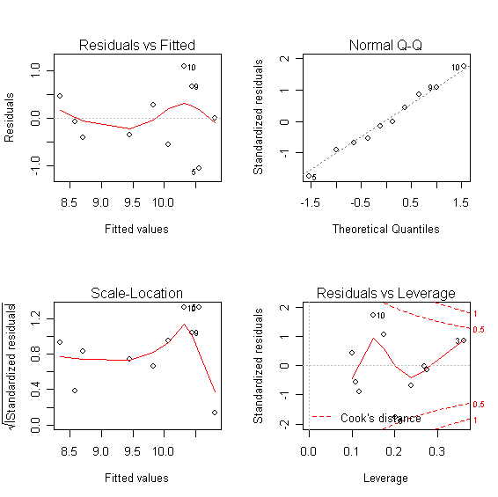
Categorical boxplots
These are a very useful diagnostic, pre-analysis tool when you have factors that describe sets of your data. For example, if the diameter and height data in cherry were collected in two parks in Leeds, our dataset might look like this.
park<-gl(2,5)
c2<-data.frame(cherry,park)
par(mfrow=c(1,2))
boxplot(diam~park,c2,main="Diameter",xlab="Park",ylab="Diam")
boxplot(height~park,c2,main="Height",xlab="Park",ylab="Ht")
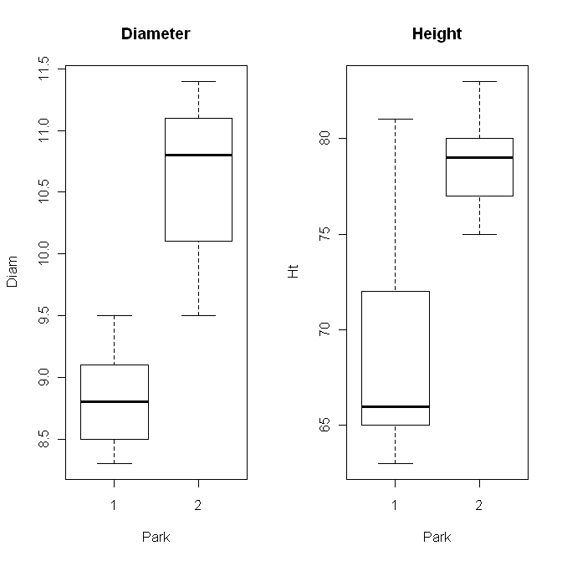

Use the mouse to resize the window so that its not so scrunched. Go to the menu bar and copy the figure as a bitmap. Open Word. Paste the figure into word. See how easy it is?
Advanced Graphics
Here, we show you how to access and use one of the most important plotting packages that comes with R, called lattice graphics.
These graphics can be instrumental in identifying and clarifying pattern in data. There are two major features –
- The panel plot – when your data is grouped in to n-levels, the package allows automated plotting of your data, split into panels by the grouping variable
- The group plot - when your data is grouped in to n-levels, the package allows automated plotting of your data, with each group specified in the same graph panel by a different symbol and colour.
search()
library(lattice)
search()
trellis.par.set(theme=col.whitebg())
xyplot(height~diam|park,data=c2) # | usually next to z on keyboard
xyplot(height~diam,groups=park,auto.key=TRUE,data=c2)

Note how search() lists the packages that are loaded. Note that library(lattice) loads a package called lattice. Using search again, confirms this. Next, xyplot() takes a call either to a “|”, which creates a two-panel plot based on the grouping factor park, or the “groups=” argument, which plots each group (park) as a separate set of points in the figure. auto.key=TRUE in the xyplot() call, creates a simple legend for the groups style plotting. trellis.par.set makes nice default colours – the originals are horrid!
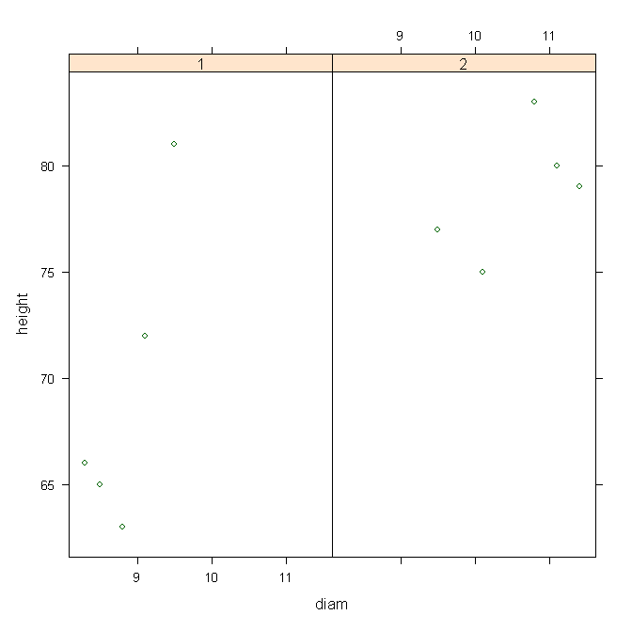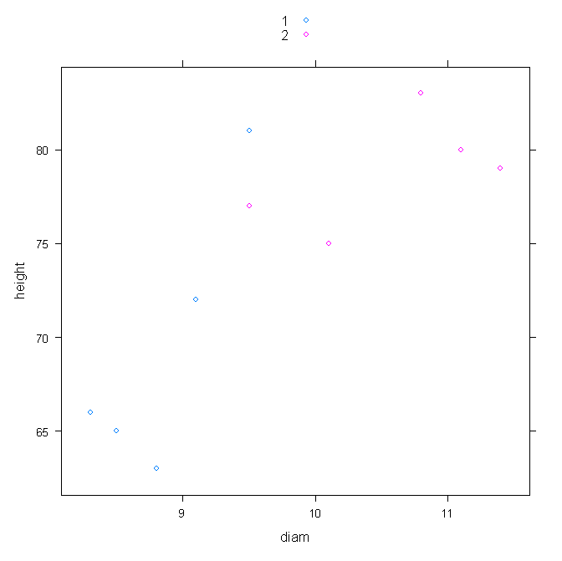
NB : it is reasonable and completely possible to combine these two graph formats. For example, with two grouping levels, we might have xyplot(height~diam|park,groups=species,data=c2) which could produce two panels based on parks, and split the data within each panel by species (TRY IT by making a third variable, species, using species<-gl(5,2).

NB2: coplot() is an alternative method for generating some
panel style plots – coplot(height~diam|park,data=c2)

From Data to Models: A final test and an intro to models
Now let’s try looking at some real data - Soay sheep morphometrics! (Thanks to Ken Wilson who owns this data)
Locate the file on the computer called soay1.csv (you may need to find the file soay1.xls on the VLE and download it to make it a csv file before saving it on your local drive). Create a script called soay.R. Begin the script by reading this file into your database, using read.csv(). Call it soay. This file contains the following data:
soay<-read.csv(“path.to.file\\soay1.csv”)

 | Variable |  |  | Description
NAME |  |  | Tag of the sheep
SEX |  |  | Sex (“M” for male, “F” for female)
COHORT |  |  | Year of birth (76-97)
HORNTYPE |  |  | Type of horn: “ABSENT”, “SMALL”, “LARGE”
CAPYEAR |  |  | Year of capture for measuring (85-97)
FORELEG |  |  | Length of foreleg (mm)
HINDLEG |  |  | Length of hindleg (mm)
WEIGHT |  |  | Body mass (kg)

Using what you learned earlier, do the following (but writing all the commands as an annotated script which you can save, reload and run again):
Begin your exploration by typing attach(soay). That puts the object soay at the top of R’s search path so R will recognize WEIGHT without the need to type soay$WEIGHT. When you finish with an object, type detach(soay).
- Produce a Report summarising the mean, medians and sample sizes of all the data in soay.
- Try str(soay)
- Produce a boxplot of HINDLEG vs. CAPYEAR; & of HINDLEG vs. SEX on the same page
- Produce a panel plot of HINDLEG~WEIGHT, split by SEX
- Produce a panel plot of HINDLEG~log(WEIGHT), split by SEX: e.g. xyplot(HINDLEG~log(WEIGHT)|SEX,data=C2)
- Carry out linear regressions on the following two relationships:
HINDLEG~log(WEIGHT) & HINDLEG~log(FORLEG)
- Produce a single plot of each of the following relationships, with the fitted line through them: HINDLEG~log(WEIGHT) & HINDLEG~log(FORLEG)
- Produce the four diagnostic plots for each regression, each set of 4 figures on one plot page.

in these notes, commands, or syntax, for R is set in courier typeface as that is the default in R
Courier type face is a bugger to separate 1 (one) from l ("ell"). If something doesn't work if you are copying make sure you haven't got your 1+l confused

